Part 3 – Verification – Section 8.3

The following screenshots in this document detail all the possible actions a user may take within WasteDrop.

Creating a new user:

1. Home Page, clicked “Sign Up”

1. Filled in registration information

1. Clicked “Create account”

Expected outcome: Creation of new account in order to use WasteDrop.

Logging in to WasteDrop

1. Sign in to WasteDrop with registered information.

1. Filled in incorrect password, clicked “Login”

1. Clicked “Login” with correct password.

1. Logged in to account home page.

Expectation: Verify creation of account and login credentials.

Logging out of WasteDrop

1. On Home screen, clocked “Log Off”

1. Confirm log off

Expectation: Log out of Waste Drop

Create a Binz:

1. Fill in Binz name under “Create new Binz below” on home page

1. Clicked “Create”

1. Refreshed page, navigate to newly created “Binz 1” on left-hand side of page

1. Clicked “Binz 1”

Expectation: Confirm the creation of a “Binz” group.

Add Item to Binz

1. Click “add items”

1. Fill in item description fields – “Add an item to bin:”, “Please Enter Item Expiration,” and “Please Enter item Quantity”

1. Click “Add item”

Expectation: Creation of item within Binz group

Updating an Item in a Binz

1. Click “update items”

1. Type name of item in “Enter name of item you wish to update,” allocate quantity.

1. Click “update item”

Expectation: Change in quantity of specified item_name

Deleting an item in Binz group

1. Click on specified Binz group

1. Clicked on “delete items”

1. Entered desired item to be deleted

1. Clicked on “delete item”

1. Refreshed page

Expectation: Removal of undesired item within Binz group

Renaming a Binz group

1. Navigate to “Rename Binz below”

1. Fill in “Enter the current name of binz” to rename and “Enter the new name of binz”

1. Clicked “Rename”

1. Navigate to “Your Binz,” identify desired renamed Binz

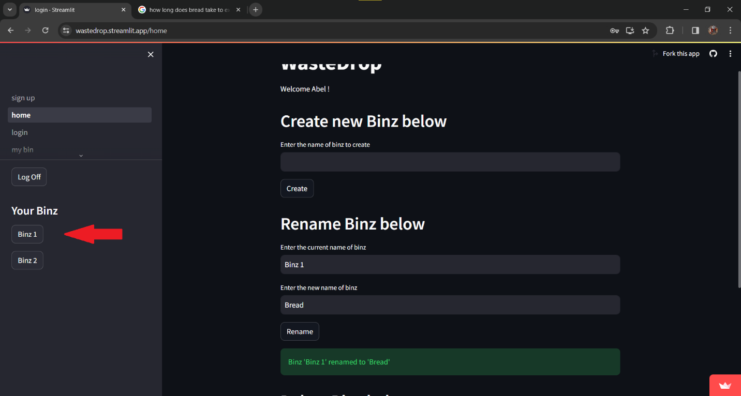

1. Click “Binz 1”

1. Refreshed page

1. Identify renamed “Binz 1” to previously specified “Bread”

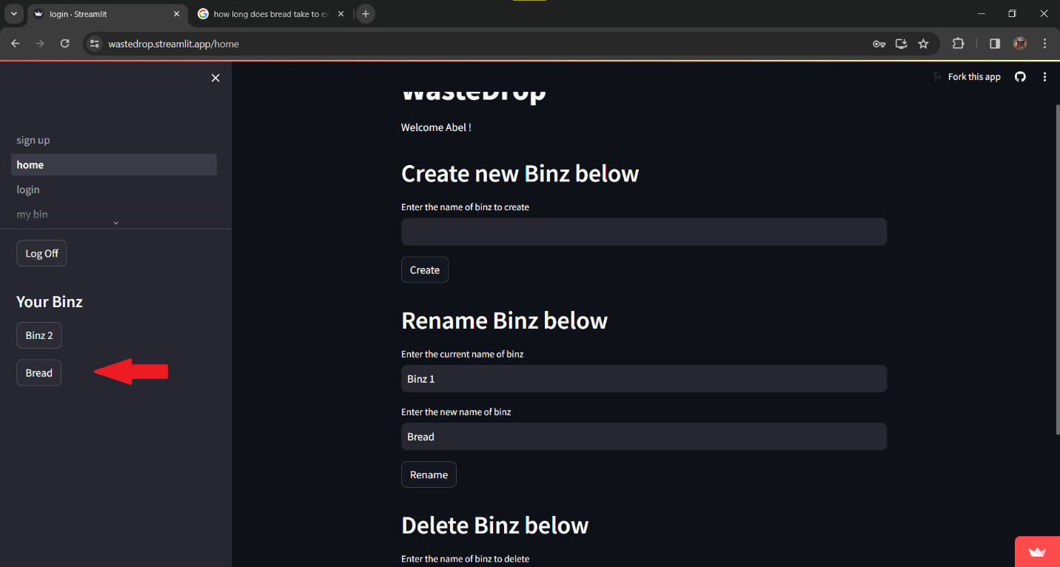

1. Clicked on “Bread”

1. Confirmed new Binz group name

Expectation: Renaming of Binz group

Deleting a Binz

1. Scroll down to bottom of page

1. Highlight “Enter the name of binz to delete”

1. Filled in undesired Binz group, typed in “Binz 2”

1. Clicked “Delete”

1. Clicked “home” on left hand side of page to refresh home page

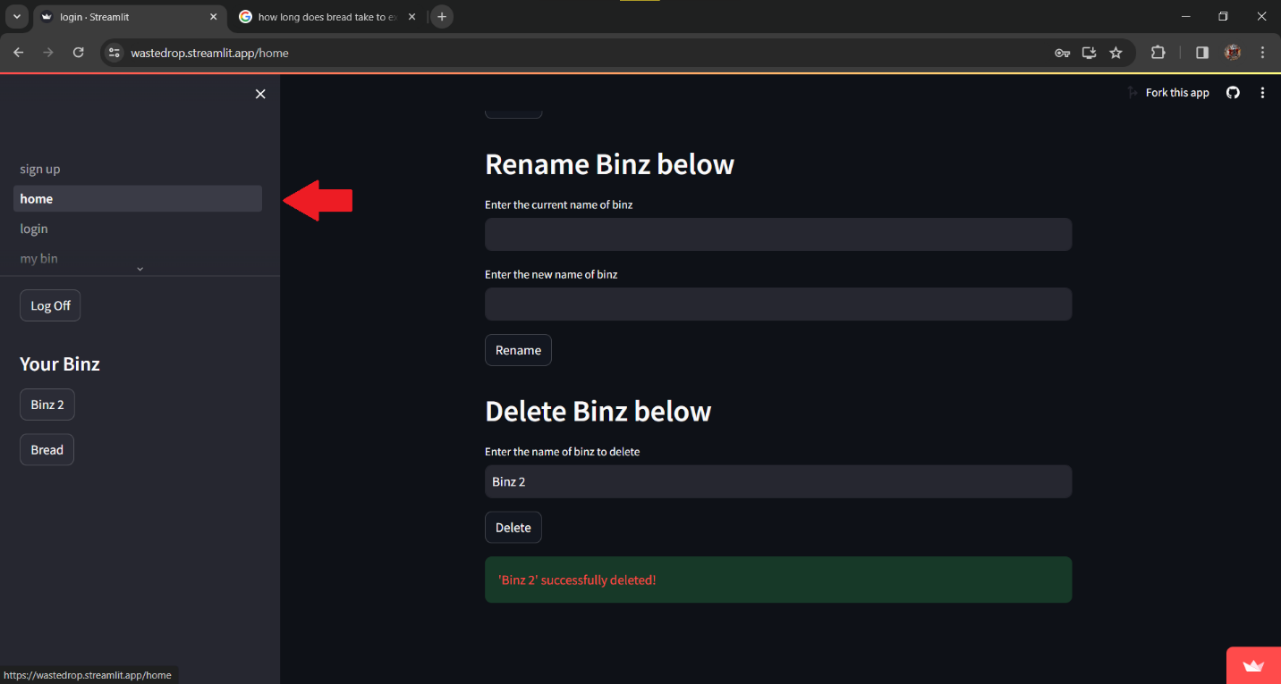

1. Confirmed the removal of undesired Binz group

Expectation: The removal of a binz group.

Section 8.4

|  |  |  |  |
| --- | --- | --- | --- |
| User Story ID | User Story Description | Test Case ID | Test Case Description |
| US001 | I want to create an account | TC001 | Verify the account creation process, ability to enter a name, e-mail, password and its confirmation |
| US002 | I want to log in | TC002 | Ensure the correct email/password combination grant access to WasteDrop |
| US003 | I want to sign out | TC003 | Verify the “sign out” button terminates the usage of the application, sends the user to the sign in page. |
| US004 | I want to create a Binz | TC004 | Verify the creation of a Binz group via the home page and verify its contents load in the next page – name, quantity, expiration date. |
| US005 | I want to add an item to the Binz I just created | TC005 | Verify the addition of an item within the binz group, entering a name, quantity and expiration date yields a return. |
| US006 | I want to update the quanity of an item in a Binz | TC006 | Verify the indicated quantity field counter works as intended. Updating the quantity retains its new quantity in the Binz. |
| US007 | I want to delete an item in a Binz | TC007 | Verify the deletion of an item within a Binz group, entering a desired item for removal and clicking delete removes the indicated item from the Binz. |
| US008 | I want to rename a Binz | TC008 | Verify the “Rename Binz below” feature on the homepage renames the specified Binz from x to y. Ensure the yielded changes retain the new value. |
| US009 | I want to delete a Binz | TC009 | Verify the “Delete Binz below” feature removes the indicated Binz. Specifying a Binz and clicking “delete” removes the Binz from the home page. |